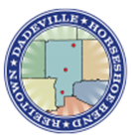

Tallapoosa County Board of Education Child Nutrition Program is committed to providing nutritious and appealing meals which follow established meal patterns. We believe students learn best and have improved behaviors when they are not preoccupied with hunger or experiencing health problems due to malnutrition. We strive to provide school environments which promote health, well-being, and the ability to learn by supporting healthy eating and physical activity as a valuable part of daily life.

**Mission Statement**

Improving child nutrition is the focal point of the Healthy Hunger-Free Kids Act of 2010. The legislation authorizes funding and sets policy for the USDA’s core child nutrition programs; the national school lunch program, and the school breakfast program, and the special supplemental nutrition program for women, infants, and children (WIC), the Summer Food Service Program, and the Child and Adult Food Care program, The Healthy Hunger-Free Kids Act allows USDA for the first time in over 30 years opportunity to make real reforms to the school lunch and breakfast programs by improving the critical nutrition and hunger safety net for millions of children Revised 2024

**Healthy Hunger- Free Kids Act**

The purpose of this wellness policy is to establish healthy habits through promotion of good nutrition and physical activity in the Tallapoosa County Board of Education School District (TCBOE). The policy is based on our mission statement, Healthy Hunger-Free Kids Act, and the current dietary guidelines.

**Purpose**

Tallapoosa County

Board of Education

Wellness Policy

Our school district references the current dietary guidelines which establish specific methods to achieve and maintain health throughout the stages of life. This ensures healthy meals are served to students, with plenty of fruits and vegetables, whole grains, fat-free and low-fat milk; moderate in sodium, low in saturated fat with zero grams of trans-fat per serving that meet calorie requirements.

**Tallapoosa County Child Nutrition Program staff works together with district staff to improve meal experiences for students and to ensure that USDA guidelines are followed by:**

* Performing serving line studies to increase efficiency, enjoyment, and time for consumption of meals to at least 10 minutes of seat time at breakfast and 20 minutes of seat time at lunch.
* Maintaining clean and safe cafeterias by following an established HACCP plan.
* Providing an option for a Second Chance Breakfast to students who arrive to school late.
* Ensuring that all snacks and drinks sold in and around schools during the school day are smart snack compliant by entering them into the Smart Snacks Calculator. Snacks/beverages will be sold only during times that do not compete with meal service: 1 hour before or 1 hour after meal service. This includes: A la Carte food/beverages, items sold in vending machines, and food sold in school stores. A listing of Smart Snacks is attached. **(Attachment 1)**
* Providing new menu offerings (fresh salads daily, Charcuterie boxes) often to improve student satisfaction.
* Decreasing food insecurity by implementing the Community Eligibility Provision, which allows all students access to free meals. Thereby making sure no one does without meals due to meal balances.
* Promotion and advertisement of free school breakfast and lunch through social media and daily announcements.
* Promotion of healthy habits through social media and the TCBOE website via quarterly newsletters. **(Attachment 2)**
* Procurement of seasonal locally grown fresh fruits and vegetables to encourage student consumption, offset costs, and help farmers.
* Maintaining a log of fundraisers to ensure student nutrition is taken into consideration during implementation.
* Allowing students access to free potable water during meals, as well as throughout the school day by the availability of water fountains in and around schools that contain filtered water.
* Using approved menu planning software to ensure compliance with established meal patterns and other regulations/restrictions.
* Child Nutrition Staff training is provided annually and

as needed according to USDA Professional Standards. The

required number of training hours and completed trainings are kept

on record in Linq software. Directors-12; Managers-10 and workers-6.

* Providing a list of suggested healthier snacks and beverages for

parents prior to classroom parties. **(Attachment 3)** Teachers also

receive lists of non-food celebration ideas and fundraising ideas.

**(Attachment 4)**

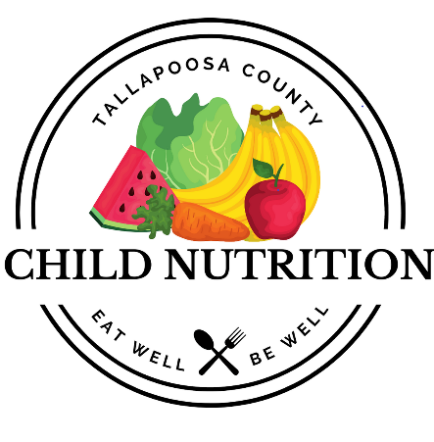



Quick Fundraising Facts

* There are no limits to fundraisers which meet smart snack standards
* Fundraisers that take place outside of school are not affected. (i.e. cookie dough sales, pizza sales)
* A school may sponsor **up to and not to exceed 30 exempt fundraisers per year, for no more than one (1) day each in length.**
* Foods sold as part of exempt fundraisers **may not be sold until one (1) hour before or after meal periods has passed.**
* Exempt fundraiser food is prohibited from being sold as a la carte item, in vending machines or in school stores, or before school.
* Marketing of foods and beverages throughout the school day should be restricted to those snacks that meet smart snack standards.

Smart Snacks in School

Fundraisers

According to U.S. Department of Agriculture (USDA) data,

school meals are the richest source of dairy in children’s

diets. A 2017 study showed 77% of daily milk consumption

and 70% of total dairy consumption for low-income children

aged 5-18 came from the national school meals programs,

underscoring the importance of school meals and milk’s role

in helping children meet their nutritional needs for growth

and development. Because most children and adolescents

don’t meet daily dairy recommendations, school meals can

help close the gap and bring students closer to nutrient

recommendations for calcium, vitamin D, potassium and

other nutrients provided by milk.

The Healthy Hunger-Free Kids Act of 2010 directed the USDA to establish nutrition standards for all foods and beverages sold to students in school during the school day, including foods sold through school fundraisers. The new Smart Snacks in School nutrition standards will help schools to make the healthy choice the easy choice by offering students more of the foods and beverages we should be encouraging – whole grains, fruits and vegetables, leaner protein, lower-fat dairy – while limiting foods with too much sugar, fat and salt.

**Foods must also meet several nutrient requirements:**

• **Calorie Limits:** Snack items: 200 calories or less ; **Entrée items:** 350 calories or less

• **Sodium Limits:** **Snack items:** 230 mg or less** ; **Entrée items:** 480 mg or less

• **Fat Limits:** **Total fat**: 35% of calories or less; **Saturated fat**: Less than 10% of calories; **Trans- fat:** zero grams

• **Sugar Limit**:35% or less of weight from total sugars

**\*\*On July 1, 2016, snack items must contain 200 mg sodium or less per item.**

**Elementary School: Pre-K-5th**

**Middle School: Grades 6-8**

**High School: Grades 9-12**

**Accompaniments**

• Must be included in the nutrient profile as part of the food item sold to help control the amount of calories, fat, sugar, and sodium added to foods.

• Examples include: **cream cheese, salad dressing, catsup, mustard, pickles, pickle relish, dips, sauces, and butter.**

**Beverages Portion Sizes**

**All schools may sell:**

• Plain water (with or without carbonation)

• Unflavored low-fat milk

• Unflavored or flavored fat free milk and milk alternatives permitted by NSLP/SBP

• 100% fruit or vegetable juice

• 100% fruit or vegetable juice diluted with water (with or without carbonation), and no added sweeteners.

Portion size limitations by school categories: Revised March 27, 2015 • Elementary schools may sell up to 8-ounce portions of milk or juice • Middle schools and high schools may sell up to 12 ounce portion of milk and juice. • There is no portion size limit for plain water. Additional “no calorie” and “lower calorie” beverage options for high school students: • No more than 20-ounce portions of calorie-free, flavored water (with or without carbonation); and other flavored and/or carbonated beverages that are labeled to contain less than 5 calories per 8 fluid ounces or 10 calories or less per 20 fluid ounces. • No more than 12 ounce portions of beverages with 40 calories or less per 8 fluid ounces, or 60 calories or less per 12 fluid ounces. School Day School Day means, for the purpose of competitive food standards implementation, the period from th

**USDA Guidelines for Smart Snacks in Schools**

**(Including snacks and/or beverages sold or served to students after the school day, including aftercare, clubs, and after-school programming on school grounds)**

**Any food sold in schools must:**

• Be a “whole grain-rich” grain product; or

• Have as the first ingredient a fruit, a vegetable, a dairy product, or a protein food; or

• Be a combination food that contains at least ¼ cup of fruit and/or vegetable; or •

* Contain 10% of the Daily Value (DV) of one of the nutrients of public health concern in the 2010 Dietary Guidelines for Americans (calcium, potassium, vitamin D, or dietary fiber)*

\***On July 1, 2016, foods may not qualify using the 10% DV criteria.**

**USDA Guidelines for Smart Snacks in Schools (Continued)**

**BEVERAGES**

Foods and beverages are caffeine-free, with the exception of trace amounts of naturally occurring caffeine-related substances.

* **Elementary schools** may sell up to 8-ounce portions of milk or juice

• **Middle schools and high schools** may sell up to a 12- ounce portion of milk and juice.

• **There is no portion size limit for plain water.**

**Additional “no calorie” and “lower calorie” beverage options for high school students:**

• No more than 20-ounce portions of calorie-free, flavored water (with or without carbonation); and other flavored and/or carbonated beverages that are labeled to contain less than 5 calories per 8 fluid ounces or 10 calories or less per 20 fluid ounces.

• No more than 12- ounce portions of beverages with 40 calories or less per 8 fluid ounces, or 60 calories or less per 12 fluid ounces.

**School Day School Day means, for the purpose of competitive food standards implementation, the period from the midnight before, to 30 minutes after the end of the official school day.**

It is important for students, parents, and staff to know:

**Nutrition Education**

Nutrition education plays a vital role in the establishment and continued success of a wellness plan. Without it, behaviors would not have a basis for change, and health would essentially deteriorate. Through this Wellness Policy, Tallapoosa County Board of Education will continue to strive to provide nutrition information to staff and students via:

* Quarterly newsletters that feature healthy behavior habits relating to families and seasons, and include healthy and appealing recipes in colorful, easy to read formats. These are available on social media and the TCBOE website.
* Training modules which promote healthy lifestyles for employees annually, and throughout the year.
* Posters throughout the schools, and in the cafeterias that encourage healthy habits for all ages.
* Purchasing and display of digital signage which provides nutrition messages and information on future menu offerings to increase participation in both students and staff while they are waiting for meals.
* Snippets of health information through social media via the cafeterias’ Facebook pages.
* Encouraging employees to model healthy eating and physical activity behaviors.
* Ensuring nutrition education is incorporated into lesson plans.

Physical Education and Physical Activity at TCBOE Schools

Tallapoosa County Board of Education follows planned physical education curriculum in accordance with the Alabama Course of Study for Physical Education.

* Students are encouraged to be physically active outside of school as well. They are encouraged to participate or join in team sports such as: (track, football, fishing, baseball, softball, tennis, and basketball); cheer, and band.
* Physical Education is taught to students in the following frequencies:
  + Elementary- 45 minutes per day
  + Middle and High School- 90 minutes per day

The Alabama Physical Fitness Assessment must be administered to grade 2-12 students, including students who receive exemptions from the State Superintendent of Education. Fitness data must be reported to the State Department of Education (Alabama Administrative Code 290-3-2)

* To become a certified physical education teacher in Alabama, individuals typically need a bachelor’s degree in physical education, including an approved educator preparation program, and completion of a student teaching practicum. This degree must be from an accredited college or university. Physical Education teachers are all required to have state-mandated trainings All PE teachers are CPR and AED certified via the Red Cross.
* .

. Community Health Promotion and Engagement

Physical Activity

. A substantial percentage of students' physical activity can be provided through a comprehensive, school-based physical activity program (CSPAP) that includes these components: physical education, recess, classroom-based physical activity, walk and bicycle to school, and out-of-school time activities. The district is committed to providing these opportunities. Schools will ensure that these varied opportunities are in addition to, and not as a substitute for, physical education. To the extent practicable, the District will ensure that its grounds and facilities are safe, and that equipment is available to students to be active. The District will conduct necessary inspections and repairs.

Physical Education

. The physical education curriculum will promote the benefits of a physically active lifestyle and will help students develop skills to engage in lifelong healthy habits, as well as incorporate essential health education concepts .

There is a PE exemption for secondary students who are in marching band. That exemption ends this year. The band, PE teacher, and school administrator collaborated to ensure that the marching band students met specific standard benchmarks that would align with both subject areas. This is the only PE exemption that we currently have. Even our students with multiple disabilities have adaptive PE. The purpose of the Alabama Adapted Physical Education and 504 Process State Guidelines is to help students develop the necessary functional skills toward independence in order to participate to the maximum extent possible in an appropriate physical education setting. The Alabama Adapted Physical Education and 504 Process State Guidelines is intended to be used by physical education teachers, special education staff, and administrators in preparation for instruction for students with disabilities as defined by Section 504 of the Rehabilitation Act of 1973 or the Individuals with Disabilities Education Act. We also offer JROTC as an alternative to PE. Validation of the Junior Reserve Officers’ Training Corps (JROTC) curriculum and plan for implementation was approved in 2006 as a substitute for the physical education credit as defined in the Alabama Administrative Code 29-3-1-.02(8)(s)(f)1

* PE is never used as a punishment for students. PE class time is neither added to or taken away as a result of student behavior. Throughout the year, students might have the opportunity to be rewarded with additional recess time, but that is separate from the PE class and administered and overseen by the classroom teacher.

Recess (Elementary) All elementary schools will offer at least 20 minutes of recess on all or most days during the school year. This program may be waived on early dismissal or late arrival days. The District will include in the health education curriculum the following essential topics on physical activity: beginning in 9th grade and continuing through 12th grade.

* The physical, psychological, or social benefits of physical activity
* How physical activity can contribute to a healthy weight How physical activity can contribute to the academic learning process
* How an inactive lifestyle contributes to chronic disease Health-related fitness, that is, cardiovascular endurance, muscular endurance, muscular strength, flexibility, and body composition
* Differences between physical activity, exercise, and fitness.
* Phases of an exercise session, that is, warm up, workout, and cool down
* Overcoming barriers to physical activity Decreasing sedentary activities, such as TV watching
* Opportunities for physical activity in the community
* Preventing injury during physical activity Weather-related safety, for example, avoiding heat stroke, hypothermia, and sunburn while being physically active

The District will promote to parents/caregivers, families, and the general community the benefits of and approaches for healthy eating and physical activity throughout the school year. Families will be informed and invited to participate in school-sponsored activities and will receive information about health promotion efforts. As described in the "Community Involvement, Outreach, and Communications" subsection, the District will use electronic mechanisms (such as email or displaying notices on the district's website), as well as non-electronic mechanisms, (such as newsletters, presentations to parents, or sending information home to parents), to ensure that all families are actively notified of opportunities to participate in school-sponsored activities and receive information about health promotion efforts. Staff Wellness and Health Promotion The DWC will have a staff wellness subcommittee that focuses on staff wellness issues, identifies, and disseminates wellness resources, and performs other functions that support staff wellness in coordination with human resources staff.

Integration and Coordination

Committee

TCBOE school district encourages input on the wellness policy by selecting participants who will be in charge of compliance with conditions established. The wellness committee consists of:

Jenny Knox- Child Nutrition Program Director, TCBOE

Candy Harkins- Child Nutrition Program Specialist

**Assessments and Evaluations**

TCBOE’s wellness policy is a working document, and will be reviewed by the committee on a periodic basis, or as needed. Meetings will have an agenda and attendance sheets for documentation. Members will assess county health statistics, effectiveness of the wellness program, and make recommendations for changes as needed. The committee will mee

A triennial assessment of the policy was recently done using the WellSAT Assessment Tool at [www.wellsat.org/triennial](http://www.wellsat.org/triennial) to ensure compliance with Federal regulations. The updated wellness policy, along with the score from the assessment, will be available, for public view on the TCBOE website at www.tallapoosak12.org. The policy has been revised to meet USDA requirements.

Attachments

**Attachment 1**

**Smart Snacks & Beverages at TCBOE Schools**

* Rich’s Savagely Sour Cherry Popsicle
* Rich’s Rainbow Polar Pole
* Mayfield Fudge Bar
* Mayfield Ice Cream Sandwich
* Rich’s Crumbles Cookie Cone
* Rich’s Birthday Cookie Cone
* Rich’s Strawberry Shortcake Bar
* Rich’s Crumbled Cookie Bar
* Banana Fudge Bomb Pop
* Rich’s Cotton Candy Twirl
* Kellogg’s Frosted Fudge Tart
* Kellogg’s Frosted Cinnamon Pop Tart
* Kellogg’s Frosted Strawberry Pop Tart
* Kellogg’s Frosted Blueberry Pop Tart
* Doritos Nacho Cheese Chips (28.30 g size)
* Doritos Ranch Flavored Nacho Cheese Chips (28.30g size)
* Ruffles Baked Cheddar and Sour Cream Chips (1.1oz)* Sysco
* Crazy Colors Fruit Roll-Ups (14g size)
* Tostitos Reduced Fat Crispy Rounds (24.80 g)
* Blue Ribbon Fudge Bar (Ordered through Sysco)
* Doritos Flamas
* Doritos Reduced Fat Wild White Nacho Flavored Tortilla Chips
* Cheetos Bakes Whole Grain Rich Flavored Snacks-Crunchy- .875oz
* Cheetos Baked Whole Grain Rich Flamin Hot Cheese Flavored Snacks
* Munchies Munch Mix Snack Mix .875oz
* Cheetos Fantastix Ranch Flavored .9oz
* Lay’s Baked Original 1.125oz
* Lays Baked BBQ 1.125oz
* Stacy’s Multigrain Pita Chips 1oz
* G2 Fruit Punch-12oz
* G2 Glacier Freeze-12oz
* G2 Grape-12oz
* Any flavor of Gatorade Zero
* Any Flavor of ICE Sparkling Water
* Poppi Prebiotic Soda (All Flavors)

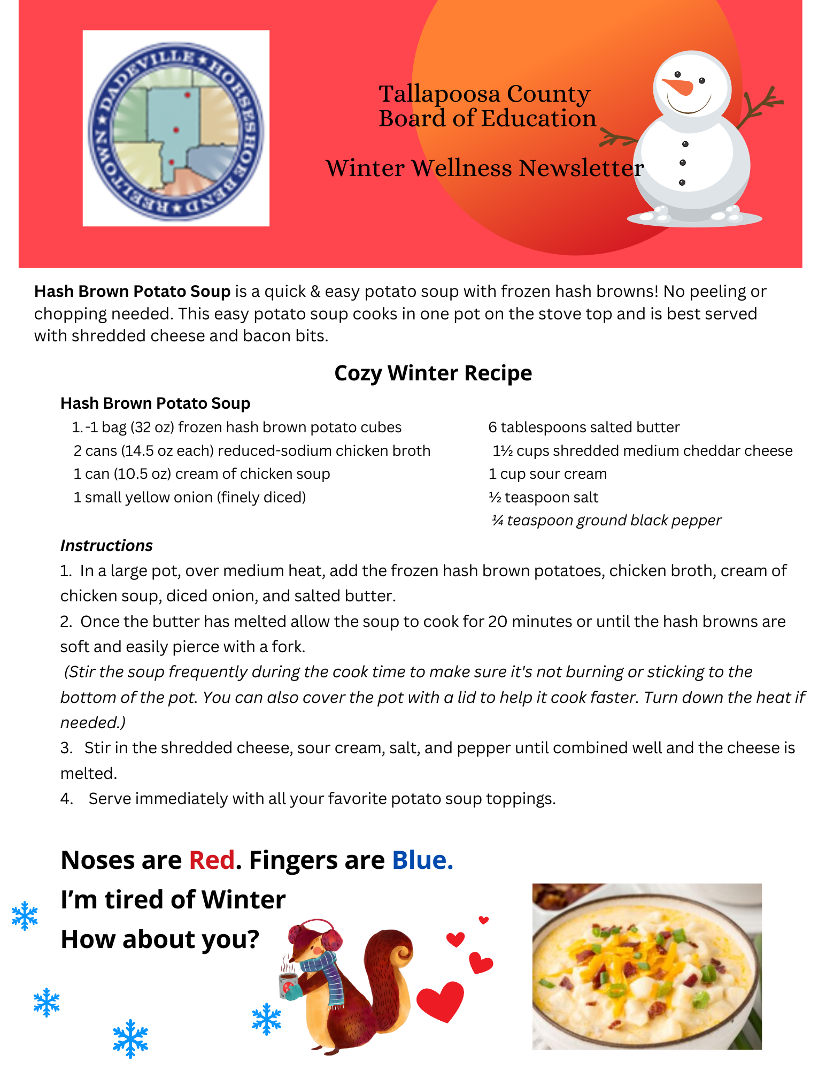**Attachment 2a- Sample Newsletter**

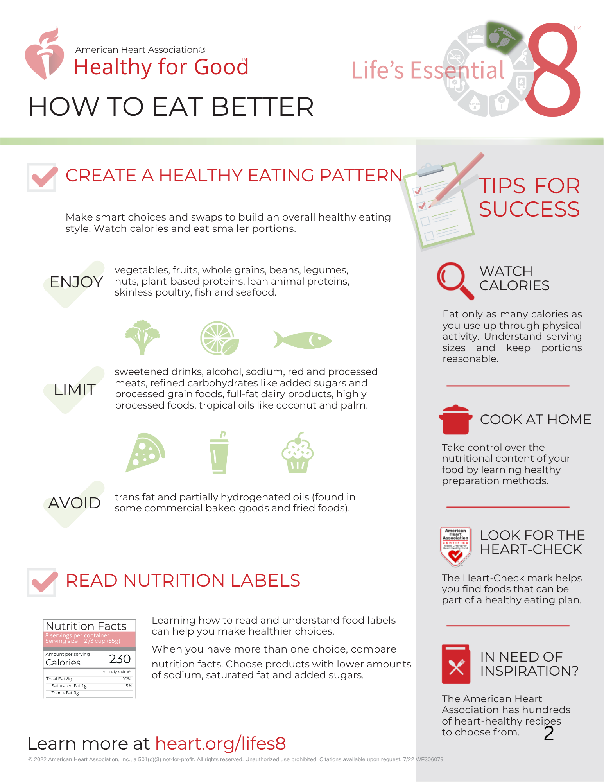**Attachment 2b- Sample Newsletter**

**Attachment 3**

Healthy Snack & Beverage Ideas*

♣ Water

♣ 100% fruit juice with no added sugar

♣ Fat-free or low fat milk

♣ Fruit smoothies (made with frozen fruit with no added sugar and fat-free or low fat yogurt)

♣ 100% fruit juice slushes with no added sugar

♣ Fresh fruit – trays, salads or kabobs

♣ Fresh vegetables – trays, salads or kabobs

♣ Fat-free or low fat yogurt (alone or as dip for fruits or vegetables)

♣ Yogurt parfaits (fat-free or low fat yogurt, fruit and whole grain cereal or granola as topping)

♣ Canned fruit or fruit cups (in water, 100% fruit juice or light syrup)

♣ Frozen fruit or fruit cups (in water, 100% fruit juice or light syrup)

♣ Frosty fruits – freeze your own fruit (frozen grapes make a great summer treat!)

♣ Dried fruit with no added sugar

♣ Whole grain crackers

♣ Low-fat cheese (serve with fruit or whole grain crackers)

♣ Hummus (serve with vegetables or whole grain crackers)

♣ Small whole grain waffles or pancakes topped with fruit

♣ Whole grain pretzels (soft or crunchy)

♣ Low-fat or air-popped popcorn (no added butter or salt)

♣ Graham crackers

♣ Small whole grain bagels or English muffins

♣ Pizza (on whole grain crust with low fat cheese and lean protein or vegetable toppings)

♣ Roll-ups on whole grain tortillas (fill with a lean protein such as ham or turkey, low fat cheese, hummus, or vegetables)

♣ Fat-free or low-fat pudding

♣ Bean quesadillas or burritos made with whole grain tortillas with salsa

♣ Whole grain cereal bars

♣ Baked whole grain tortilla chips with salsa or bean dip

♣ Baked chips (small portions)

*Check ingredient statements and nutrition information to ensure items meet the USDA Smart Snacks in School nutrition standards. Ensure food allergies of any participants are known before serving any food item.

Pair foods together for an afternoon snack to power youth up for their activities, whether that is physical activity or educational activities. Combine a lean protein with a fruit or vegetable, such as sunflower seeds dried raisins. Or a low-fat dairy food and whole-grain rich choice, like string cheese and whole grain crackers. Try low-fat dairy and fruit – yogurt and strawberries. Pair a whole-grain rich food with a lean protein by spreading hummus on a whole grain tortilla. Or serve a whole-grain rich food and vegetable, such as a whole grain cereal bar and cherry tomatoes. Get creative! For more information on healthy snacking or finding healthy snacks and beverages, visit healthiergeneration.org

**Source: healthiergeneration.gov**

**Attachment 4**

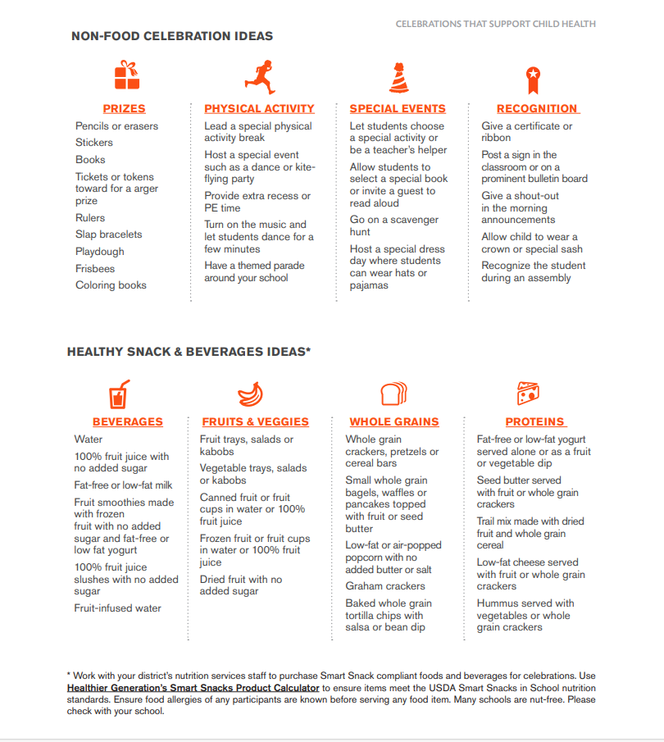

**Attachment 5**

Healthy Fundraising

Fundraising Alternatives

Many new school fundraising strategies are developed with school financial needs and concerns about student nutrition in mind. Alternatives to selling items with poor nutritional value are as follows, but are not limited to:

* Wrapping Paper
* Fresh Fruit
* High Quality Produce
* Nuts and Trail Mix
* Popcorn
* Decorations
* Wreaths
* Cookbooks
* Kitchen ware
* Restaurant Fundraiser
* School Spirit Items
* Family Game Nights
* Auctions
* Talent Shows
* Flowers
* Candles
* Tupperware
* Bike-a- thon
* Walk-a-thon
* Garage Sale
* Car Washes

Resources

Centers for Disease Control and Prevention: www.cdc.gov

Triennial Assessment Tool: wellsat.org/dashboard

Model School Wellness Policies: [www.schoolwellnesspolicies.org](http://www.schoolwellnesspolicies.org)

Dietary Guidelines for Americans 2020-2025: [www.health.gov](http://www.health.gov)

United States Department of Agriculture: [www.usda.gov](http://www.usda.gov)

Alliance for a Healthier Generation: www.healthiergeneration.org

**Nondiscrimination Statement**

In accordance with federal civil rights law and U.S. Department of Agriculture (USDA) civil rights regulations and policies, this institution is prohibited from discriminating on the basis of race, color, national origin, sex, disability, age, or reprisal or retaliation for prior civil rights activity.

Program information may be made available in languages other than English. Persons with disabilities who require alternative means of communication to obtain program information (e.g., Braille, large print, audiotape, American Sign Language), should contact the responsible state or local agency that administers the program or USDA’s TARGET Center at (202) 720-2600 (voice and TTY) or contact USDA through the Federal Relay Service at (800) 877-8339.

To file a program discrimination complaint, a Complainant should complete a Form AD-3027, USDA Program Discrimination Complaint Form which can be obtained online at: <https://www.usda.gov/sites/default/files/documents/ad-3027.pdf>, from any USDA office, by calling (866) 632-9992, or by writing a letter addressed to USDA. The letter must contain the complainant’s name, address, telephone number, and a written description of the alleged discriminatory action in sufficient detail to inform the Assistant Secretary for Civil Rights (ASCR) about the nature and date of an alleged civil rights violation. The completed AD-3027 form or letter must be submitted to USDA by:

mail:  
U.S. Department of Agriculture  
Office of the Assistant Secretary for Civil Rights  
1400 Independence Avenue, SW  
Washington, D.C. 20250-9410; or

fax:  
(833) 256-1665 or (202) 690-7442; or

email:  
[Program.Intake@usda.gov](mailto:program.intake@usda.gov)

 This institution is an equal opportunity provider.